## CLR

.NET provides a run-time environment, called the common language runtime, that runs the code and provides services that make the development process easier.

## Responsibilities of CLR:

1. Managed code benefits from features such as
2. cross-language integration,
3. cross-language exception handling,
4. enhanced security,
5. versioning,
6. deployment support,
7. a simplified model for component interaction,
8. debugging
9. profiling services.

The language compilers emit the metadata. The runtime uses this metadata to locate and load classes, lay out instances in memory, resolve method invocations, generate native code, enforce security, and set run-time context boundaries.

The runtime automatically handles object layout and manages references to objects, releasing them when they are no longer being used. Objects whose lifetimes are managed in this way are called managed data. Garbage collection eliminates memory leaks as well as some other common programming errors.

The runtime provides the following benefits:

* Performance improvements.
* The ability to easily use components developed in other languages.
* Extensible types provided by a class library.
* Language features such as inheritance, interfaces, and overloading for object-oriented programming.
* Support for explicit free threading that allows creation of multithreaded, scalable applications.
* Support for structured exception handling.
* Support for custom attributes.
* Garbage collection.

.Net provides 2 ways to tackle the unmanaged objects.

1. Finalize method
2. IDisposable implementation

Finalize method: The System.Object class have a virtual method Finalize. The implementing type must override this method to release the resources. There will be a Finalization queue to insert objects in it, and later GC can release them. The GC will call the Finalize method in a non-deterministic, hence it should be used carefully.

IDisposable interface: The type must implement the method Dispose().

***Dispose() will be called manually (or via using(…)) to de allocate memory of un managed resources. If you want to handover this de allocation of memory for un managed resources to GC, then provide destructors for the class, which eventually calls the finalize() method (it actually put such objects in finalization queue, later GC will come and reclaim their memory). The point to note here is de allocation of memory is immediate in case of Dispose() and hence it is more efficient, whereas Finalizers depend on GC to run for this purpose, so objects which are no longer used will stay till the GC runs next time and destroy them.

# **Difference Between dispose() and finalize() in C#**

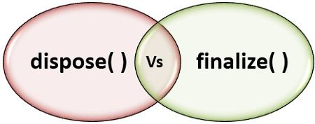Methods dispose() and finalize() are the methods of C# which are invoked to free the unmanaged resources held by an object. The dispose() method is defined inside the interface IDisposable whereas, the method finalize() is defined inside the class object. The main difference between dispose() and finalize() is that the method **dispose**() has to be explicitly invoked by the user whereas, the method **finalize()** is invoked by the garbage collector, just before the object is destroyed.

Let us study some other differences between them with the help of a comparison chart shown below.

## **Content: dispose() Vs finalize() in C#**

1. [Comparison Chart](https://techdifferences.com/difference-between-dispose-and-finalize-in-c-sharp.html#ComparisonChart)
2. [Definition](https://techdifferences.com/difference-between-dispose-and-finalize-in-c-sharp.html#Definition)
3. [Key Differences](https://techdifferences.com/difference-between-dispose-and-finalize-in-c-sharp.html#KeyDifferences)
4. [Conclusion](https://techdifferences.com/difference-between-dispose-and-finalize-in-c-sharp.html#Conclusion)

### **Comparison Chart**

| **BASIS FOR COMPARISON** | **DISPOSE( )** | **FINALIZE( )** |
| --- | --- | --- |
| Defined | The method dispose( ) is defined in the interface IDisposable interface. | The method finalize( ) id defined in java.lang.object class. |
| Syntax | public void Dispose( ){ // Dispose code here } | protected void finalize( ){ // finalization code here } |
| Invoked | The method dispose( ) is invoked by the user. | The method finalize( ) is invoked by the garbage collector. |
| Purpose | Method dispose( ) is used to free unmanaged resources whenever it is invoked. | Method finalize( ) is used to free unmanaged resources before the object is destroyed. |
| Implementation | The method dispose( ) is to be implemented whenever there is a close( ) method. | The method finalize( ) is to be implemented for unmanaged resources. |
| Access specifier | The method dispose( ) is declared as public. | The method finalize( ) is declared as private. |
| Action | The method dispose( ) is faster and instantly disposes an object. | The method finalize is slower as compared to dispose |
| Performance | The method disposes( ) performs the instantaneous action hence, does not effect the performance of websites. | The method finalize( ) being slower affects the performance of the websites. |

### **Definition of dispose()**

The dispose() method releases the unmanaged resources that are held by an object of the class. The unmanaged resources are files, data connections, etc. The method dispose() is declared in the interface **IDisposeable** and it is implemented by the class by implementing the interface IDisposable. This method is not called automatically. The programmer has to implement it manually when you are creating a custom class that will be used by others.

The method has the following syntax:

public **void** dispose( ){

// Dispose code here

}

In the above syntax, you can observe that the method is declared as public. It is because this method is defined in the interface IDisposable and it has to be implemented by the class that implements this interface. So, to provide accessibility to the implementing class, the method is declared as public.

This method is invoked manually by the code of a program as it is implemented to invoke. The methods performance is fast, and it instantly frees the resources held by the object of a class.

### **Definition of finalize()**

The finalize() method is defined in the **object** class. It is used for cleanup activities. This method is called by the garbage collector when the reference of an object is not used for a long time. Garbage collector frees the managed resources automatically but if you want to free the unmanaged resources like file handle, data connection, etc., the finalize method has to be implemented manually. The garbage collector invokes the method finalize() just before it destroys the object completely.

The syntax of the method finalize():

protected **void** finalize( ){

// finalization code here

}

In the syntax above, the method finalize() is declared as protected. The reason behind this is, the method finalize() must not be accessible from outside the class, and it must only be accessible to the garbage collector.

The finalize() method affects the cost of the performance as it does not free the memory instantly. In C# the finalize method is called automatically with destructors.

## **Key Differences Between dispose() and finalize()**

1. The method dispose() is defined in an interface **IDisposable**. On the other hand, the method finalize() is defined in the class **object**.
2. The method dispose() has to be manually invoked inside the code by a programmer, while the method finalize is automatically invoked by the garbage collector before it destroys the object.
3. The method dispose could be invoked anytime, whereas the method finalize is invoked by the garbage collector when it finds that that object has not been referenced for a long time.
4. The method dispose() is implemented in a class after implementing the interface IDisposable. The method finalize() has to be implemented only for **unmanaged resources** because the managed resources are automatically freed by the garbage collector.
5. The access specifier of the method dispose() is public as it is defined in the interface IDisposable and it would be implemented by the class that implements this interface hence, it should be public. On the other hand, the method finalize() has protected access specifier so that it should not be accessible to any member outside the class.
6. The method dispose() is fast and frees the object instantly hence, it does not affects the performance cost. The method finalize() is slower and does not free the resources held by the object instantly.

### **Conclusion**

It is suggested to use method dispose() over the method finalize() as it is faster than finalize. Also, it could be called any time, when needed.

Garbage Collector: It has 3 generations (0,1,2).

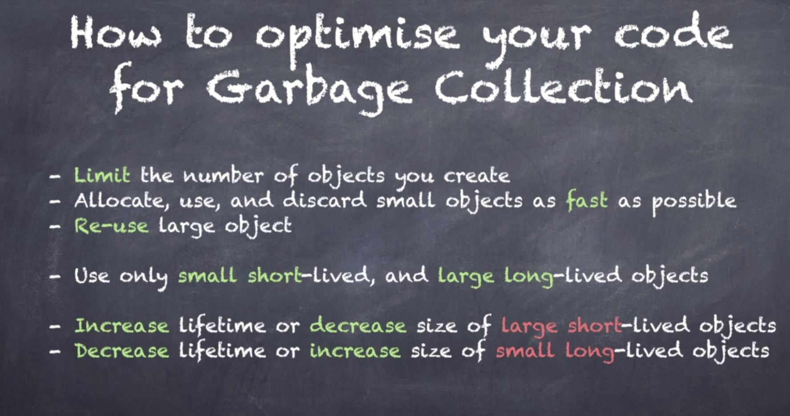

Finalizer: The destructors written for the objects are responsible for pushing the objects into finalization queue. The running of Finalizers in non-deterministic. Hence, we should not use the destructors.

The objects which are using destructors, will not be cleaned up by the GC. Instead they will be pushed into a queue called Finalization queue. Eventually a separate thread written to clean this finalization queue will wakes up and clean the items in it.

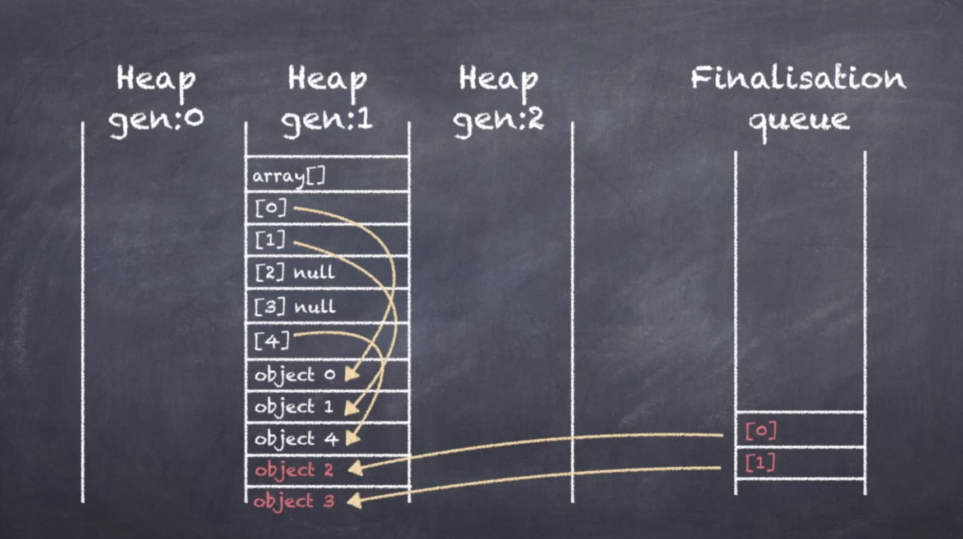

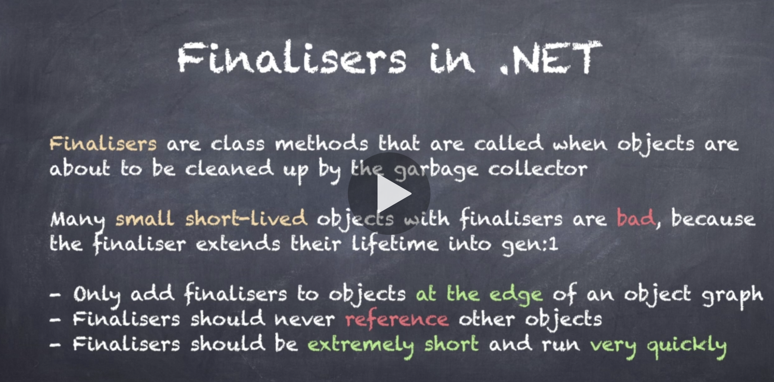

Dispose Pattern: When you implement IDisposable.Dispose() in your class, you need to suppress from finalizing this object. As Dispose will do everything to release the memory for this object. If you let Finalizer to run, then it may un-necessarily push the object in Gen – 1 of GC. So you need to suppress the finalization.

Public void Dispose()

{

Dispose(true);

GC.SuppressFinalize(this);

}

The using() will automatically call the Dispose() method.

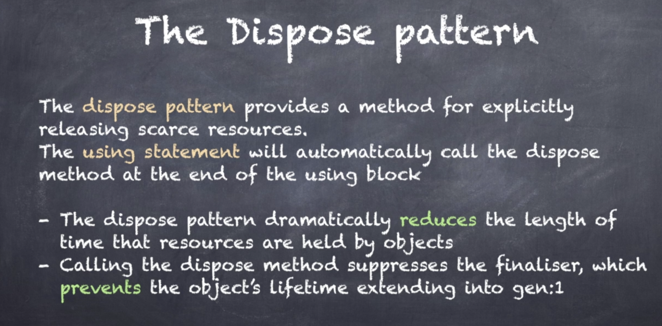

Tips to improve memory allocation in your programs.

1. Avoid boxing and unboxing
2. Don’t do string concatenation (as strings are immutable), instead use string builders.
3. Use structs instead of classes wherever possible.
4. Always Pre-Size collections
5. Avoid calling .ToList() on LINQ expressions